click on SCHEDULE & ETA. This our guest services for customer that are not billed directly by WM. Account number is not needed only the address.

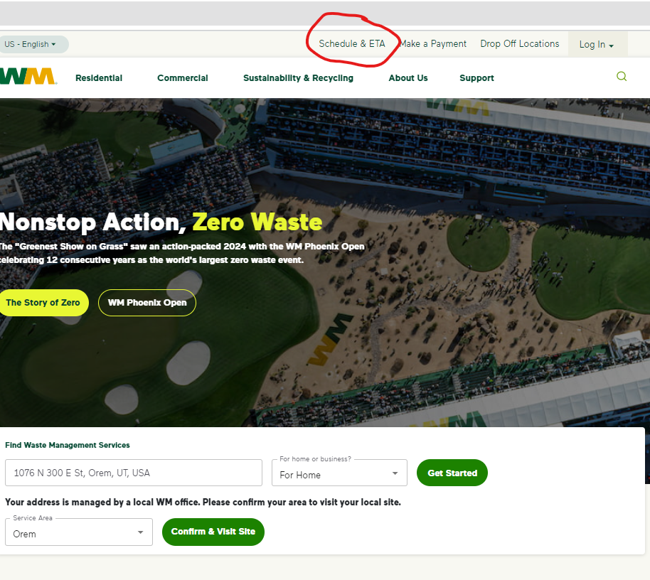

On the drop down box click on search by address, type in address it will populate underneath, then click on the correct address, click on verify.
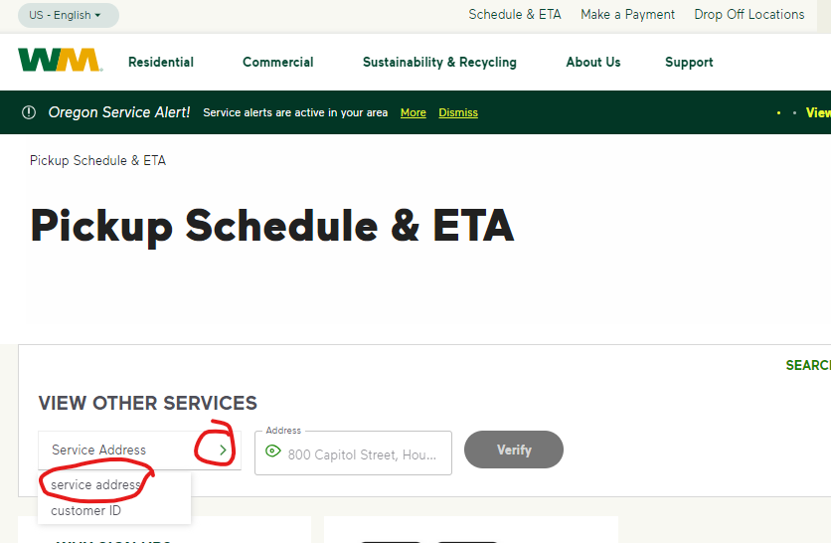

I entered 6916 W 9720 N (just randomly picked this one). Then click on Select Services for the trash or recycle can. Since the service day is within a few days there is not an option to report a missed pickup, but will once the service has passed. There is also an option on the right bottom screen to chat with virtual assistant. Will prompt the user answering questions, but if still not answering can type need live rep.

